

**MONEYMATE**

**(Website Development)**

**SUMMER APPLICATION PROJECT**

**Submitted By**

**Patel Zalak Bipinkumar**

**(Reg. No. 20220701020)**

**In partial fulfilment of the award of the Degree**

**of**

**BACHELOR OF SCIENCE**

**in**

**COMPUTER SCIENCE**

**UNITEDWORLD INSTITUTUE OF TECHNOLOGY**

**KARNAVATI UNIVERSITY**

**Uvarsad, Gandhinagar, Gujarat-382422**

**NOVEMBER 2024**

**KARNAVATI UNIVERSITY**

**UNITEDWORLD INSTITUTUE OF TECHNOLOGY**

**Uvarsad, Gandhinagar, Gujarat-382422**

**BONAFIDE CERTIFICATE**

Certified that this project titled “**MoneyMate**” is the bonafide work of “**Patel Zalak Bipinkumar (Reg. No. 20220701020)**” who carried out the Summer Application Project Work under my supervision.

|  |  |
| --- | --- |
| Prof. Roshni Ramnani  SUPERVISOR  Assistant Professor  Unitedworld Institute of Technology  Karnavati University | Dr. KUSUM LATA AGARWAL  HEAD OF THE INSTITUTION  Professor & Dean  Unitedworld Institute of Technology  Karnavati University |

Submitted for the summer application project work viva-voce examination held on__________________

INTERNAL EXAMINER EXTERNAL EXAMINER

DECLARATION

I declare that this project report title **MoneyMate** submitted in partial fulfilment of the degree of B. Sc. in (Computer Science)/ with specialization in Artificial Intelligence and Machine Learning/Data Science) is a record of original work carried out by me under the supervision of **Prof.** **Roshni Ramnani** and has not formed the basis for the award of any other degree or diploma, in this or any other Institution or University. In keeping with the ethical practice in reporting scientific information, due acknowledgements have been made wherever the findings of others have been cited.

<Signature>

Patel Zalak Bipinkumar

20220701020

ACKNOWLEDGEMENT

I feel highly honored to extend my sincere gratitude to our beloved President, Shri. Ritesh Hada, Karnavati University for having provided all facilities to carry out this project work.

I would like to acknowledge the constant and kind support provided by our Dean, Dr. Kusum Lata Agarwal, M.E., Ph.D., who supported us in all our endeavors and been responsible for inculcating us all through our career.

I record my deep sense of the thanks to my supervisor **Prof.** **Roshni Ramnani**., Professor, for his valuable support and continuous guidance.

It is a pleasure to express my gratefulness to my beloved parents for providing their support and confidence to me and my heartfelt thanks to our entire department staff members, beloved friends directly and indirectly who helped me during the tenure of my project.

Patel Zalak Bipinkumar

# ABSTRACT

MoneyMate, an application used for tracking expenses and splitting bills among groups and individuals. Tracking expenses efficiently is essential is todays fast moving world as money management becomes the primary goal for each and every individual.

This application MoneyMate provides us an updated functionality of adding members in group for splitting bills and also it has a facility of emailing the partner or other members of group to join the application for better and effective use.

Personal expenses can also be tracked in this website for users personal count of money management and user have a choice to delete the expense. Personal use of this application helps in making overview of weekly and monthly expenditure.

In group splits for this application user can easily add a group and name it with name of trip or something else then we can add members into the group and adding their email so that there is a functionality of sending email to members to let them join group. Creating groups, adding members and all functionalities are there in website.

This approach is made in MERN Stack technology also known as full stack development which can make fully interactive website along with strong database and backend logic.

**Table of** **Contents**

ABSTRACT 5

List of figures 6

1.INTRODUCTION 7

*1.1 Introduction* 7

*1.2 Overview of Platform* 8

*1.3 Key Components of Platform* 8

*1.4 Tools and Infrastructure for Implementation* 8

2.DESIGN AND IMPLEMENTATION STRATEGY 8

*2.1 Description of Project* 8

*2.2 Implementation* 8

*2.3 Applications and Features* 9

3.DATA ACQUISTION & PLANNING 11

*3.1 Source of Data* 11

*3.2 Methodology Applied* 12

4.RESULTS AND DISCUSSION 13

5.CONCLUSION 13

6.FUTURE WORK 13

7.APPENDICES 14

# 

# 

# List of figures

Figure 1 FlowChart of Project **Error! Bookmark not defined.**

Figure 2 Data Flow Diagram 11

Figure 3 Expenses Database Table 12

Figure 4 Groups Database Table 12

Figure 5 Users Database Table 12

Figure 6 PaymentStatus Database Table 13

Figure 7 VS Code Backend Connection 14

Figure 8 VS CODE for Frontend Connection 14

Figure 9 User Login/Registration 15

Figure 10 Dashboard 15

Figure 11 Personal Expenses 16

Figure 12 Adding Group for Bill Splitting 16

Figure 13 Bill Splitting members Group 17

Figure 14 adding expense for splitting 17

Figure 15 Settlement of payment 18

Figure 16 Sending Emaill 18

Figure 17 Email 19

Figure 18 Users Table 19

Figure 19 Expenses Table 20

Figure 20 Groups Table 20

Figure 21 PaymentStatus Table 21

# 1.INTRODUCTION

## *1.1 Introduction*

This Web Application is used to maintain and track records of expense by an individual and bill splitting among friends or family. Expenses might be of any kind such as travel budgets, household costs and team splitting which can sometimes lead to confusion and conflicts. A user-friendly and transparent platform is created to perform this various tasks.

## *1.2 Overview of Platform*

Personal and group expenses can be managed by MoneyMate web application such as splitting bills among groups and managing personal expenses. In this application there is a functionality of adding members and splitting wisely and monitor payment status making efficient collaboration.

## *1.3 Key Components of Platform*

Front-End: React is used to make responsive interface for users.

Back-End: Node.js and Express.js powers logic on Server side.

Database: For database storage MongoDB is used.

Integration: Seamless user experience is observed as a result of smooth communication.

## *1.4 Tools and Infrastructure for Implementation*

Technology: MERN STACK (MongoDB, Express.js, React, Node.js)

Development Environment: VS Code, npm package management, Git for version control.

Efficient, user-centric platform and scalable use can be reflected from this application as a result of this infrastructure.

# 2.DESIGN AND IMPLEMENTATION STRATEGY

## *2.1 Description of Project*

An stream line work flow is observed throughout the process resulting in easy user access. There is a flexibility of creating different group for users to easily split bills and input expenses for sharing and noting the expenses. In this application payment status of the user can also be detected.

## *2.2 Implementation*

Front-End: Bootstrap is used to style the page and react is used to make the page responsive for user to interact easily and gain positive user response.

Back-End: Routing, API development, Server-side logic etc is handled and functioned by Node.js and Express.js which can handle data efficiently.

Database: Well-Structured Schema is used to store data in MongoDB in which data for Expense, PaymentStatus, User, Group etc is stored.

Routing: REST API manage real-time data retrieval and managing client-server communication.

## *2.3 Applications and Features*

Features:

It can record and track individual and group expenditure.

It can split bill automatically among group members as user includes that member in particular expense.

It can send email to the member in group to join the application for further use.

Financial transactions can be done smoothly with use of UPI Payments.

Can check if partner has paid or not.

Applications:

Can easily manage personal finance. Able to manage event and trips expense of group. Can record expense for personal user. User-Friendly and Robust technology can be built by this features of website.

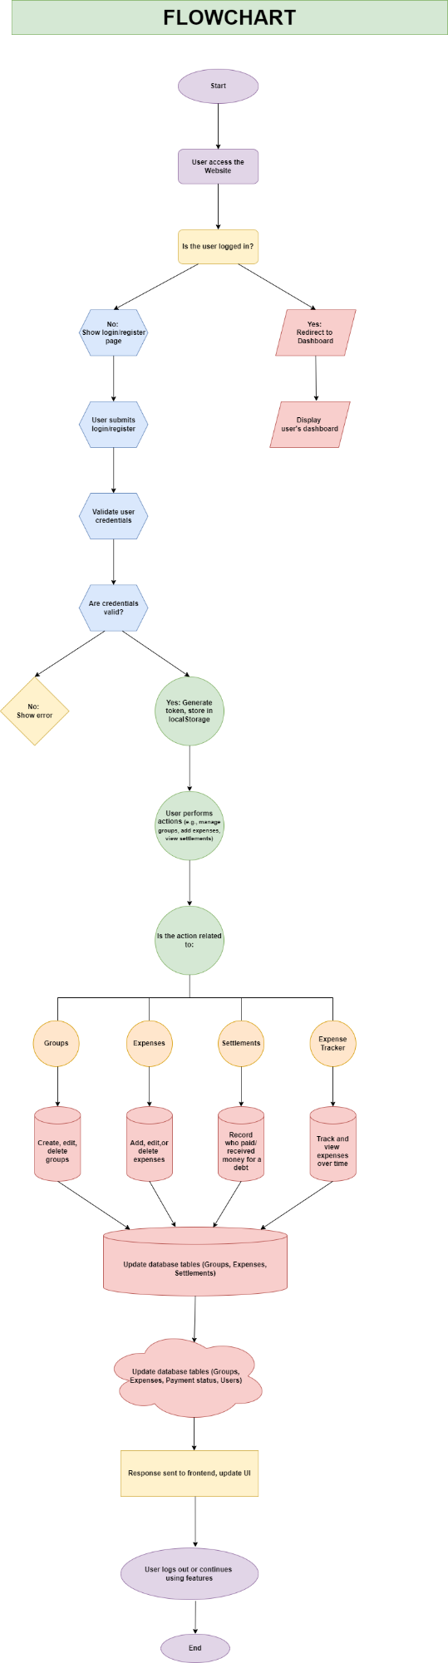

Figure 1 Workflow

# 3.DATA ACQUISTION & PLANNING

Data Flow Diagram

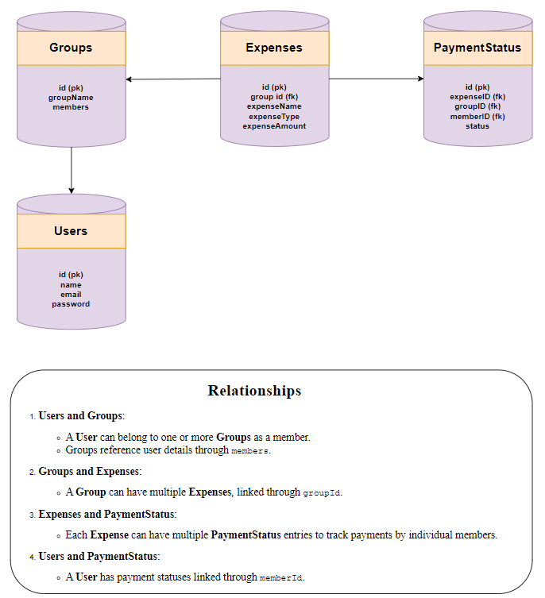

Figure 2 Data Flow Diagram

## *3.1 Source of Data*

In MongoDB data is stored for user when user logins, then expenses and group details is also recorded along with PaymentStatus.

## *3.2 Methodology Applied*

Structured Schema is designed for groups, users and expenses. To make sure data is efficient for website.

Database are connected to each other with use of relationships of data for linkage.

Middleware functions and validation rules enforce the consistency of data.

Data Dictionary

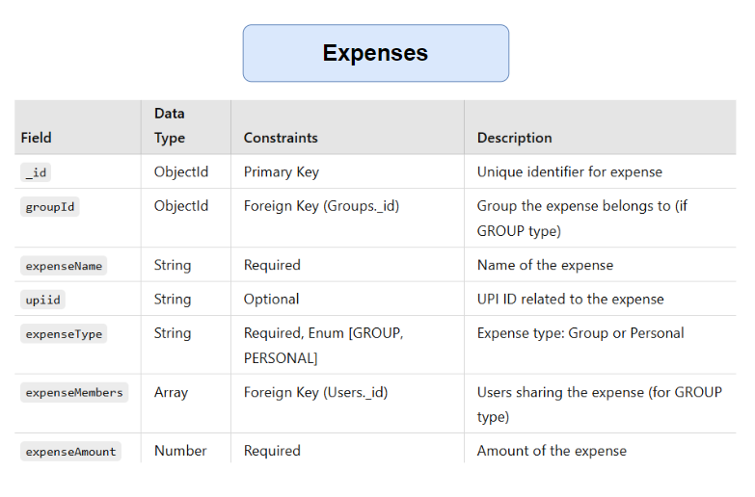

Figure 3 Expenses Database Table

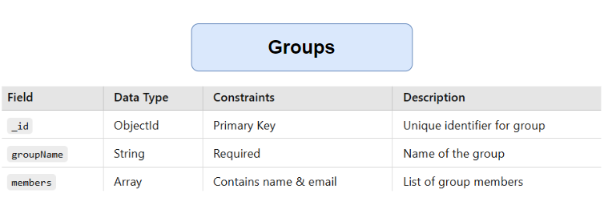

Figure 4 Groups Database Table

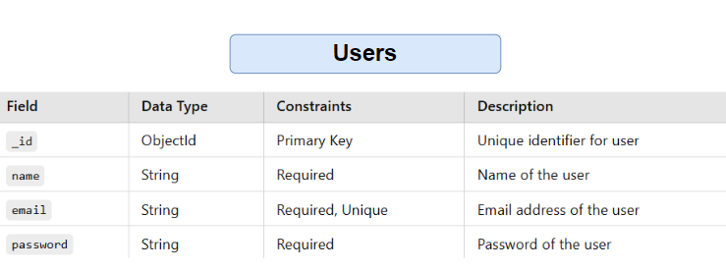

Figure 5 Users Database Table

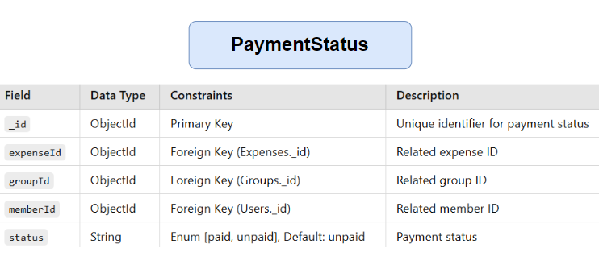

Figure 6 PaymentStatus Database Table

# 4.RESULTS AND DISCUSSION

This project mainly aims in resulting seamless user interaction for tracking expense and splitting bills for making easy management of money using MERN Stack which enables smooth and easy use for users. Key challenges are database handling, error handling, API optimization, and efficient frontend. Performance optimization is done to make sure fast user interaction without any error.

# 5.CONCLUSION

Efficient tracking of expense and splitting of bills among friend and family during tours or costs of house per month this app can play significant role in managing the accounts of user personally and in groups. This is possible with help of MERN Stack which is fully-flagged technology used for financial management.

# 6.FUTURE WORK

Future Enhancements in MoneyMate can be in AI Integration, Enhanced Payment Features, Multi-Currency Support, Custom Notifications, Offline Availability, Custom notifications etc can make this web more responsive and user friendly resulting in great convenience and accessibility.

# 7.APPENDICES

VS CODE Backend Connection

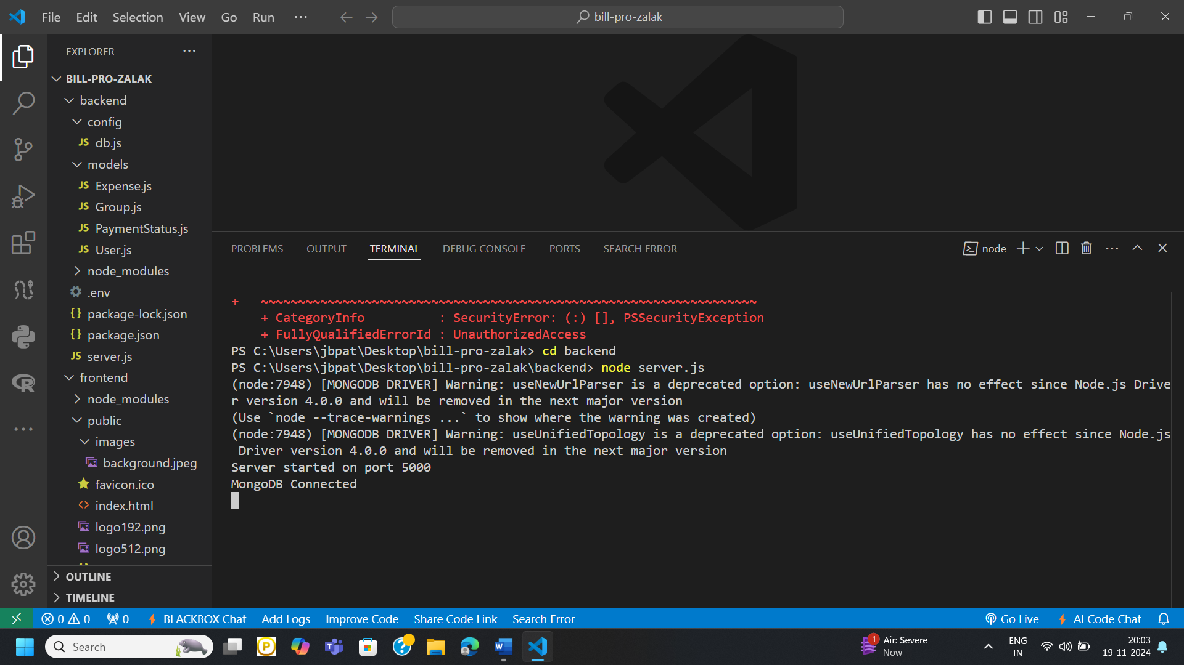

Figure 7 VS Code Backend Connection

VS CODE for Frontend Connection

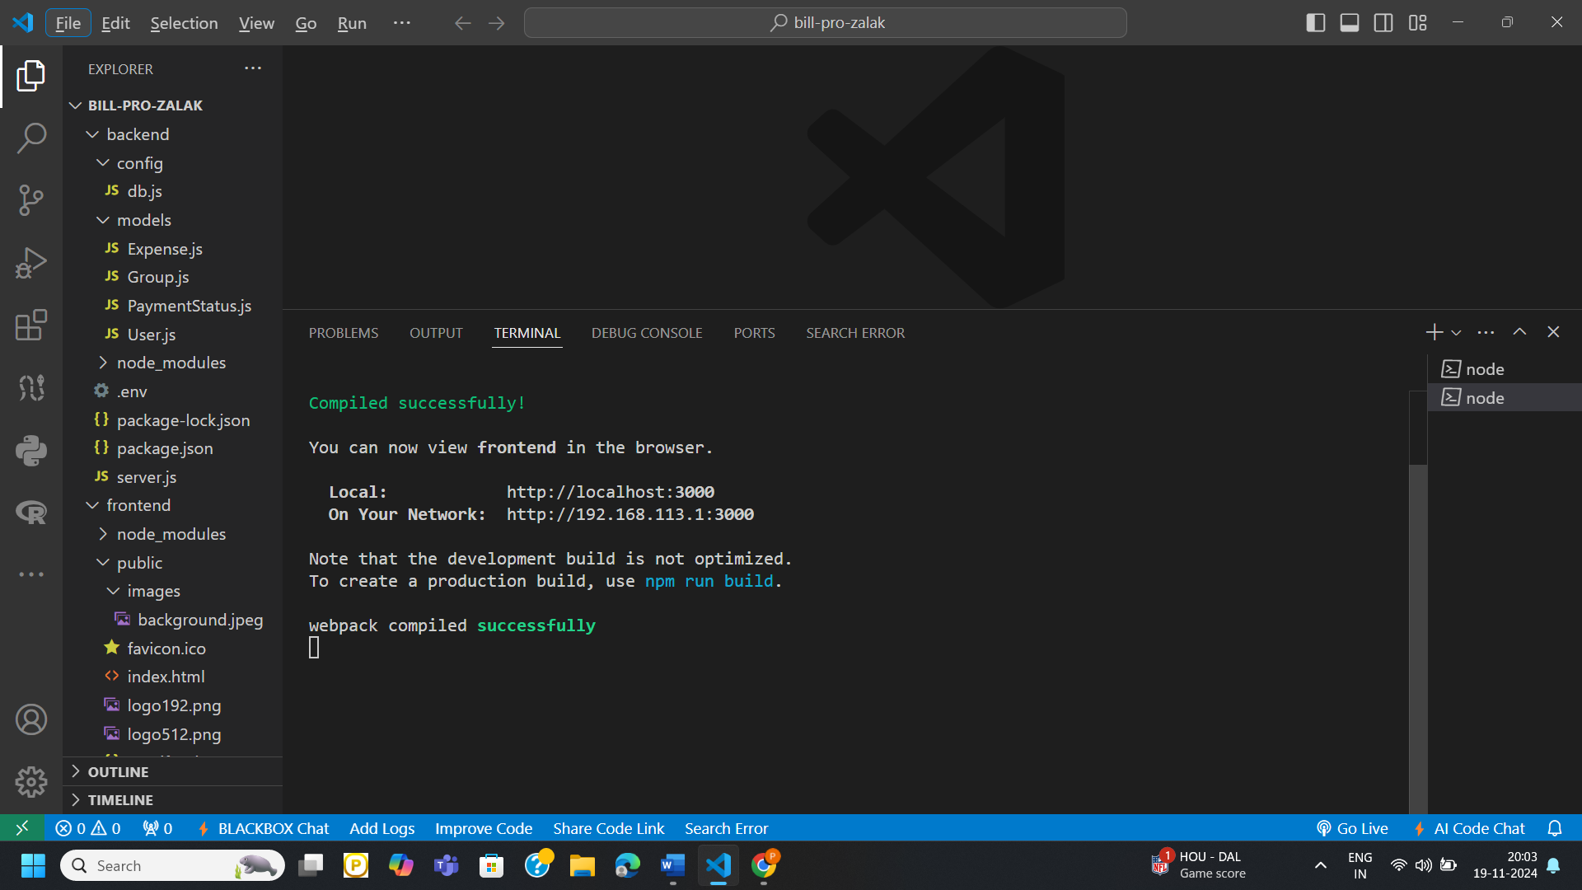

Figure 8 VS CODE for Frontend Connection

User Registration and Login on frontend

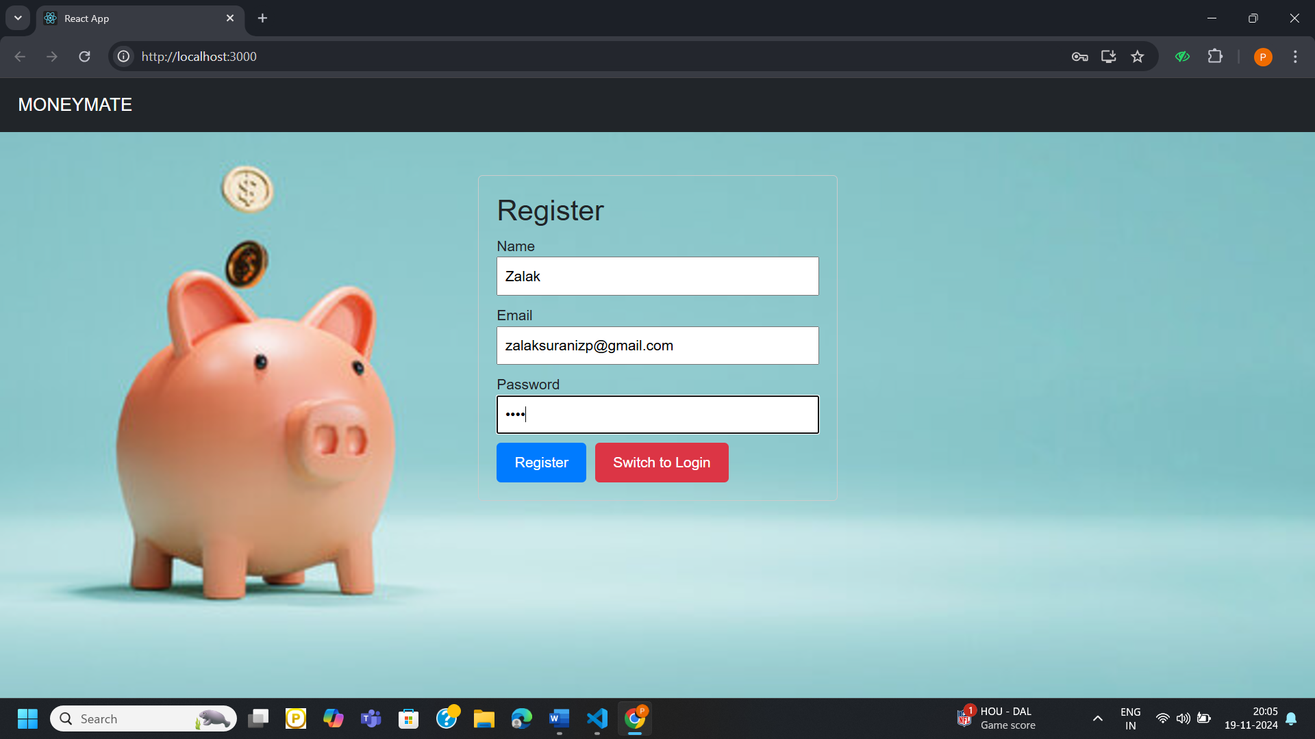

Figure 9 User Login/Registration

Dashboard   
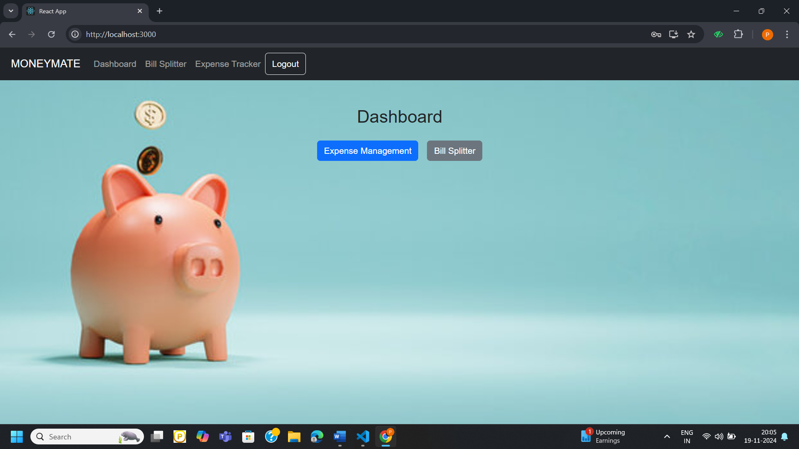

Figure 10 Dashboard

Personal Expenses can be added and deleted.

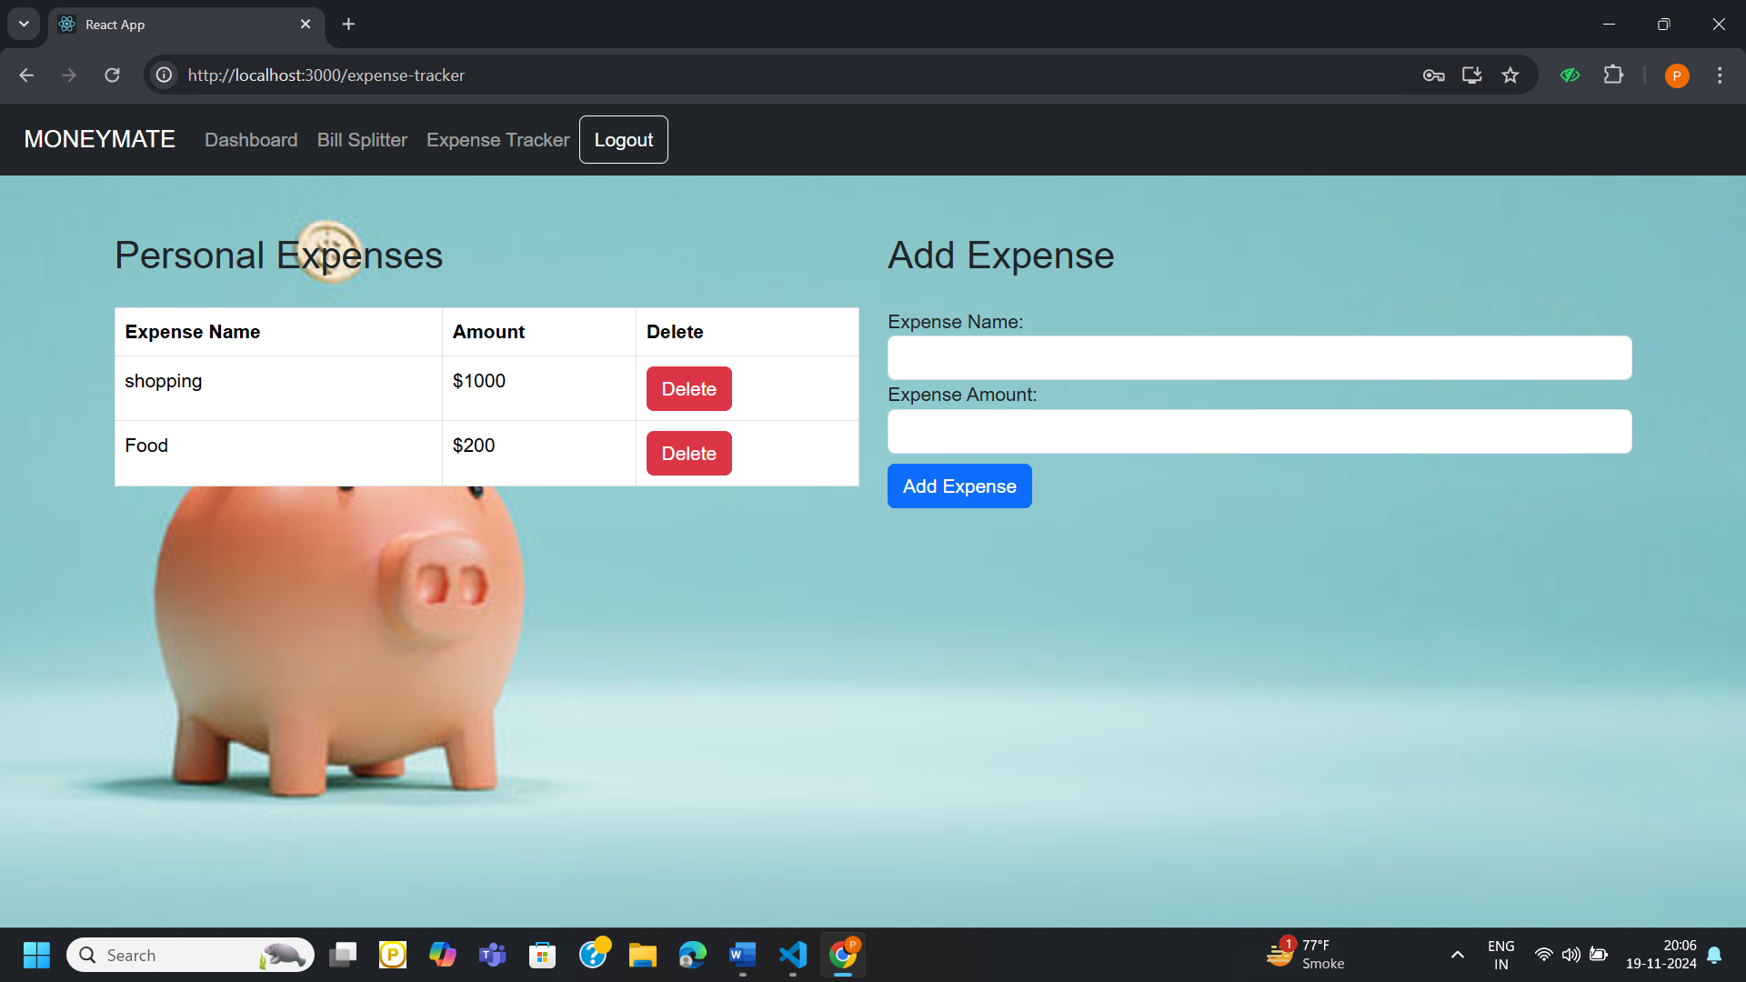

Figure 11 Personal Expenses

Moving towards Bill Splitter

Adding Group

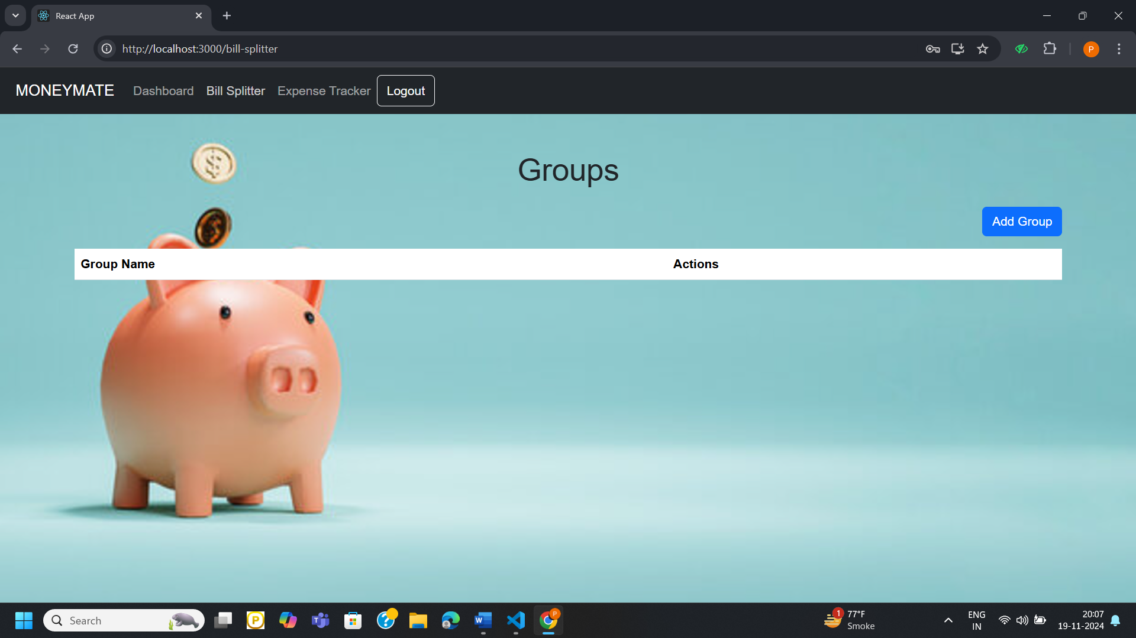

Figure 12 Adding Group for Bill Splitting

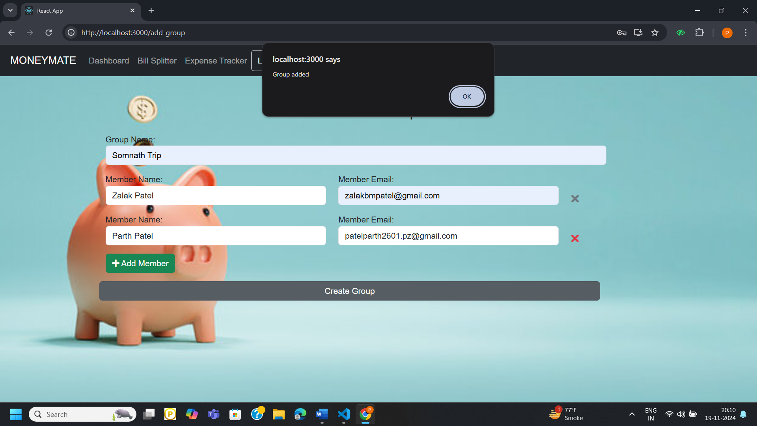

Figure 13 Bill Splitting members Group

Expense can be added and settlement can be done from here

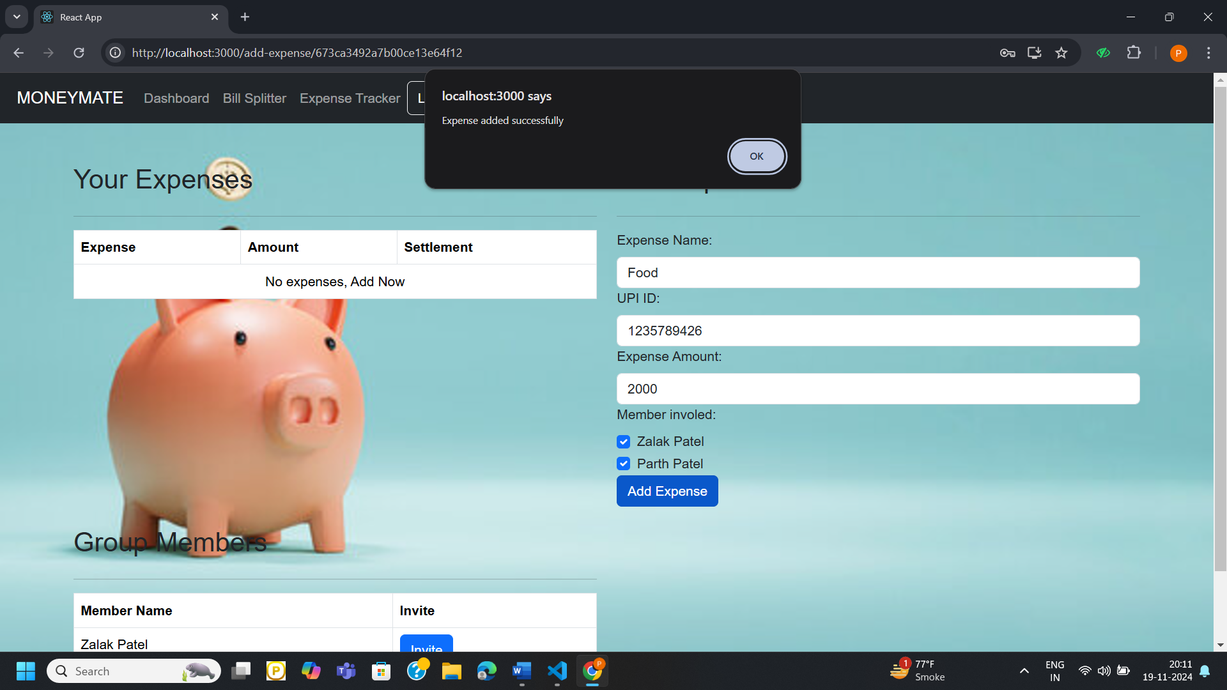

Figure 14 adding expense for splitting

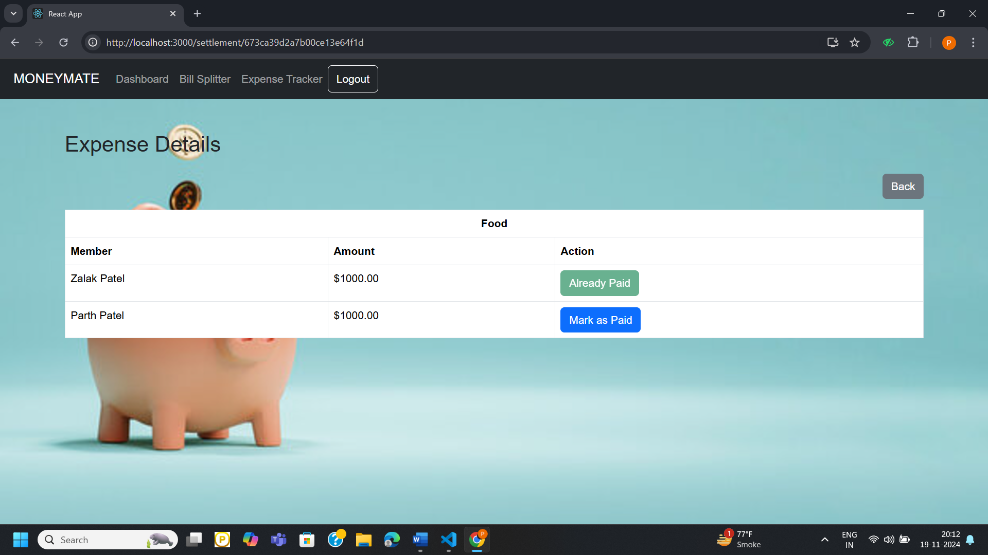

Figure 15 Settlement of payment

User can send invitation link to other members of group which can be reflected in members email.

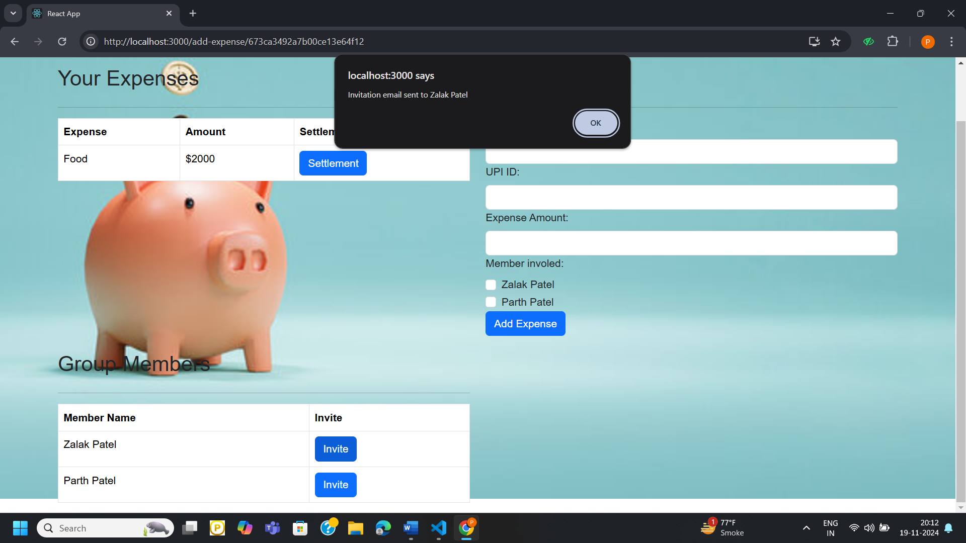

Figure 16 Sending Emaill

Reflection in partner members email

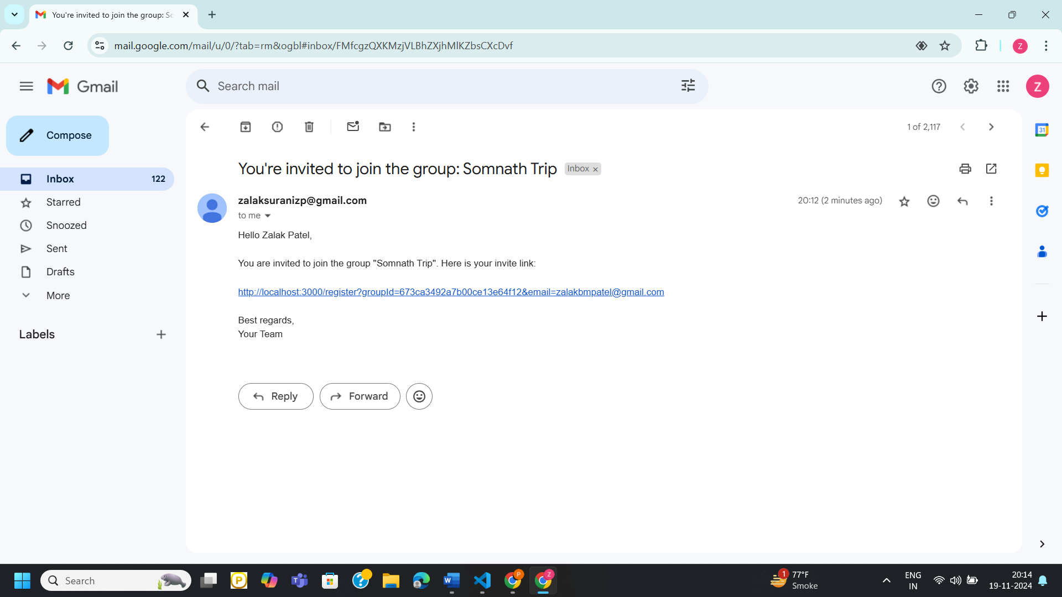

Figure 17 Email

MongoDB Database

Users table

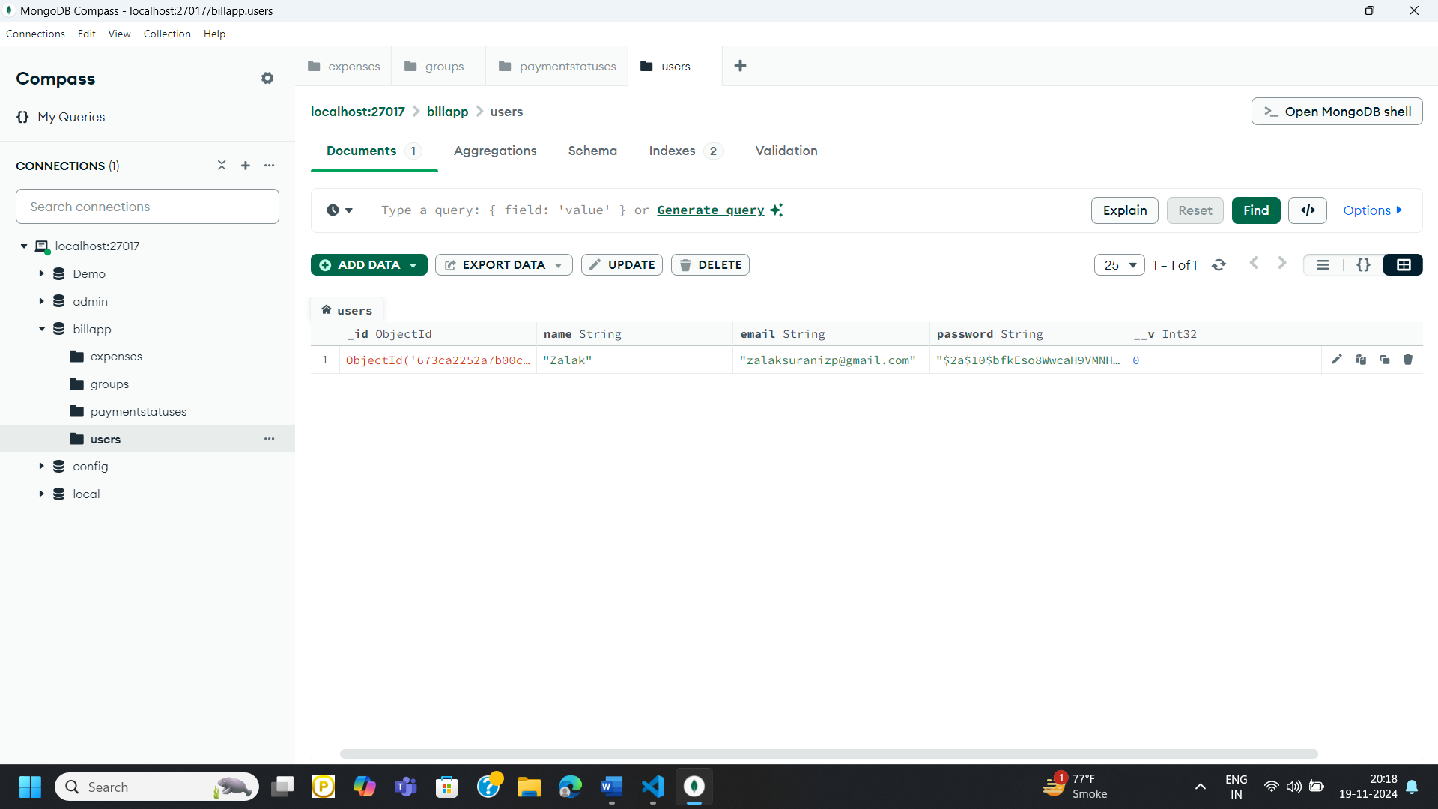

Figure 18 Users Table

Expenses table

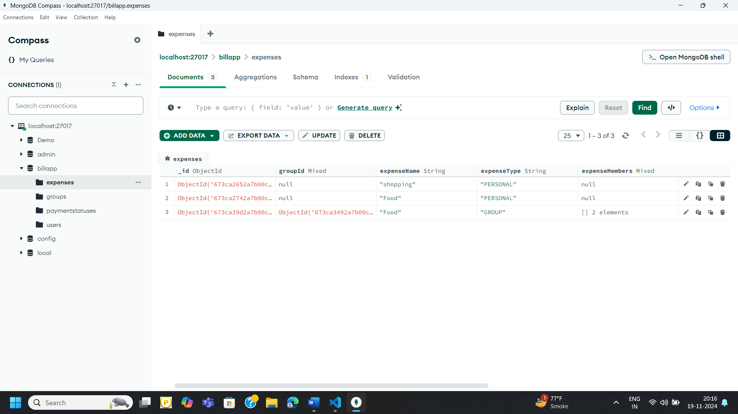

Figure 19 Expenses Table

Groups table

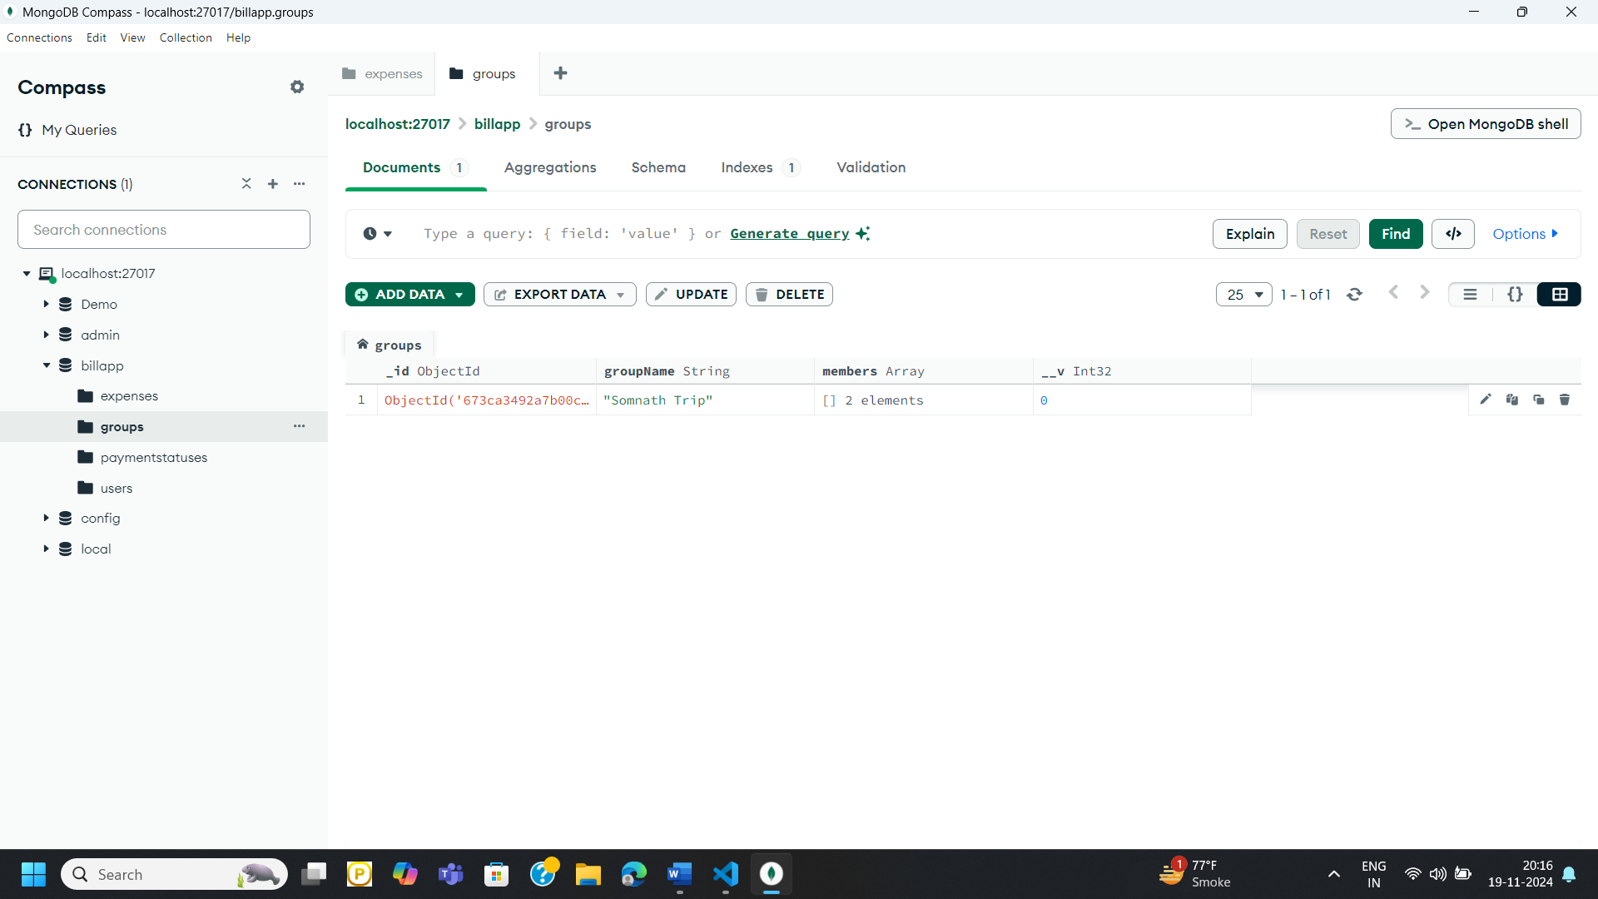

Figure 20 Groups Table

PaymentStatus table

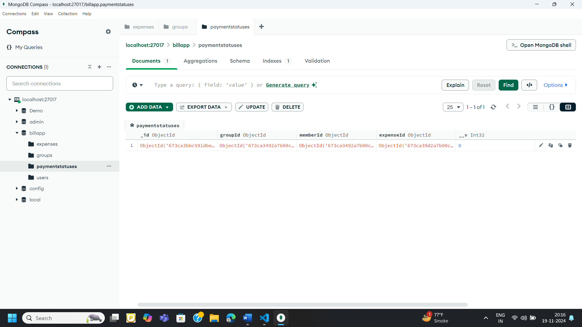

Figure 21 PaymentStatus Table